GROUPING LIVING THINGS
(BIOLOGICAL CLASSIFICATION)

The order of classification for all living things is as follows.

Kingdom
Phylum
Class
Order
Family
Genus
Species

Mnemonic to remember this order:

Kings Play Chess On Flimsy Glass Squares

At each level, the similarities between the members of the group increases.

i.e. At the lowest level (species), all members are very much alike.

Generally, the scientific name includes the genus and species.

e.g. Dog - Canis familiaris.
Human - Homo sapien.
Bottle-nose dolphin - Tursiops truncatus.

At the first level there are five kingdoms - animals, plants, fungi, protists, and monera.

Animals
• Eat other organisms to get energy (are dependent on them).

Plants
• Make their own food by photosynthesis using sunlight.

carbon dioxide + water + energy food (sugars) + oxygen

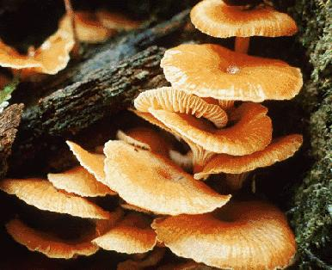
Fungi
• Mushrooms, toadstools, bread mould, yeasts.
• Don't photosynthesise (no chlorophyll) so they grow
on dead material.
• Reproduce by spores.
• Most are decomposers - they breakdown dead
material.
• Some are parasites - they grow on living things and
get their nutrients.
e.g. Ringworm on humans, powdery mildew on plants.

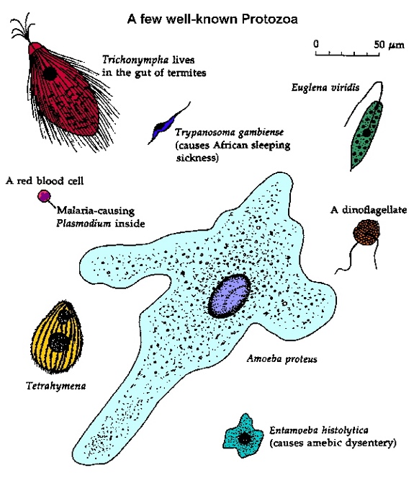
Protists
• Most are single-celled organisms; some are
multi-celled (seaweed).
• Algae - photosynthesise but have no roots, stems
or leaves like plants.

Monera
• Bacteria, blue-green algae.
• All are single-celled.
• Bacteria breakdown dead material; can cause
diseases.

LOOKING AT MONERA

Helpful Bacteria

• Good bacteria in our intestines fights off bad bacteria such as salmonella.
• Bacteria on the skin and in the mouth also fights bad bacteria and protects us.
• Bacteria in the gut gives the body vitamin K.
• Cheese and yoghurt is made by bacteria that curdles milk and separates it into
solid and liquid.
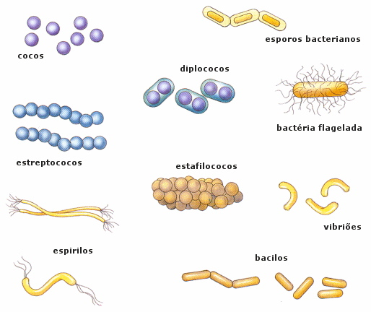
• Bacteria makes soil healthy by breaking
down dead matter to provide nutrients
for plants.

Harmful Bacteria

• Cause food poisoning by spoiling food.
• Cause diseases such as cholera, meningitis,
tetanus and legionnaire's disease.
• Causes diseases in plants and animals.

